**PART 1: Overview and Cloud Computing**

**Task 1.1**

**Cloud computing offers several benefits for retail management systems:**

**1.Scalability:**

Cloud computing allows retailers to scale their infrastructure up or down based on demand. This is particularly useful for retailers experiencing sudden increase in traffic, ensuring they can handle peak loads without investing in excess hardware.

**2.Cost Efficiency:**

Retailers can reduce their capital expenditure or hardware and maintenance by utilizing cloud services, which operate on a pay as you go model. This eliminates the need for upfront infrastructure investments and allows retailers to allocate resources more efficiently.

**3.Flexibility and Accessibility:**

Cloud based retail management systems can be accessed from anywhere with an internet connection, providing flexibility for employees to work remotely or access data while on the go. This accessibility enhances collaboration and decision-making across different locations.

**4.Data Security:**

Cloud provides typically invest heavily in robust security measures, often exceeding what individual retailers can afford. This includes encryption, firewalls, and regular security audits, providing retailers with peace of mind, regarding the safety of their data.

**5.Improved Performance and Reliability:**

Cloud providers offer high-performance computing resources and reliable infrastructure, ensuring that retail management systems run smoothly without downtime.

**6.Scalable data Analysis:**

Cloud Computing enables retailer to leverage advanced analytics and machine learning capabilities to analyze large volumes of data, such as customer behavior, sales trends, and inventory management. This allows retailers to make data-driven decisions and optimize their operations for better performance and profitability.

**Task 1.2**

**Cap Ex and Op Ex models of financing IT Infrastructure, Providing Examples when each model might be preferred.**

**Cap Ex Model of Financing IT Infrastructure:**

**Cap Ex:**

Cap Ex refers to one-time upfront costs incurred for assets that will be used in the future. A capital purchase shows up in the company balance sheet over its lifetime. The business expects to derive value from the asset for a period longer than a single tax year. Since budgeting for Cap Ex involves setting some money aside for these types of purchases.

**Example**

Before Starting an organization, we must invest huge budget for infrastructure which includes hardware and software asset purchase costs.

Asset upgrading costs, such as adding to the memory in the server.

Patents, trademarks, copyrights (i.e., intangible assets).

Buildings (e.g., data centres).

**Op Ex:**

Op Ex refers to the day-to-day operational expenses that support the business. These typically include general and administrative expenses, employee wages, research and development, maintenance, repair costs, etc.

**Example:**

Maintenance, Rent

Online retail management based on cloud computing comes under mostly Op Ex and based on some scenarios Cap Ex is used.

**PART 2**

**Understanding Public, Private, and Hybrid Clouds**

**TASK 2.1**

Public cloud

Services offered to public internet; anyone can signup

Ex: train ticket booking

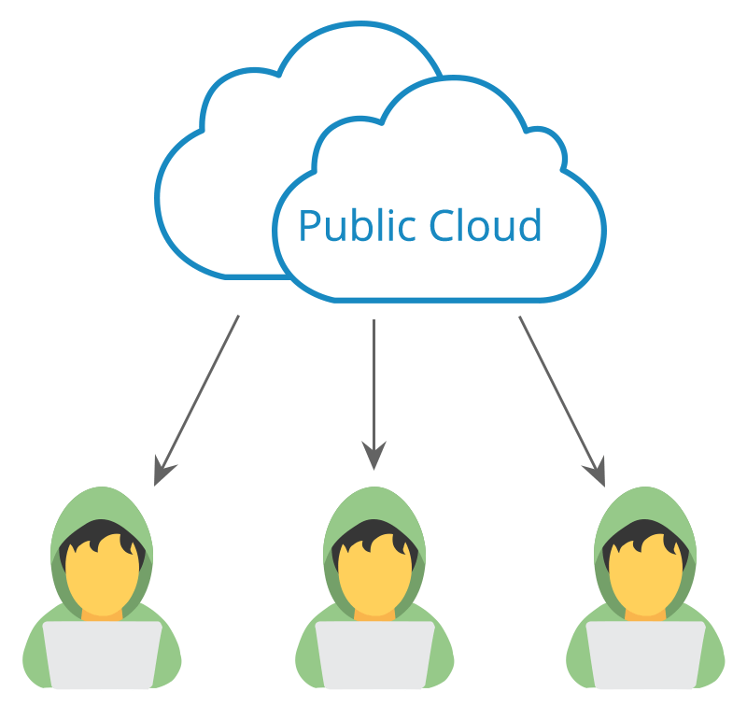

Private cloud

Providing services to selected users and organizations.

Ex: organization

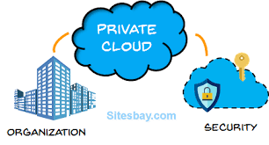

Hybrid cloud

Combination of public and private

Ex: bank

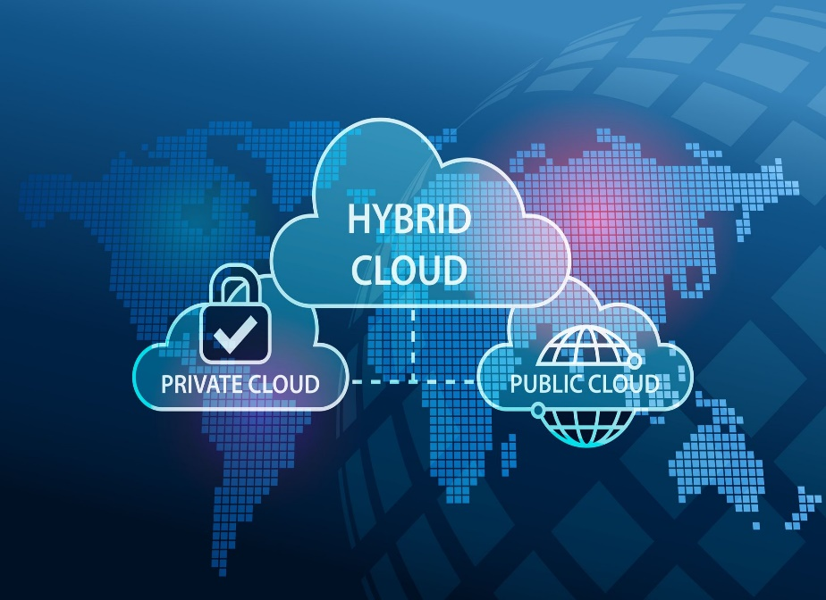

**TASK 2.2**

**For each cloud model, list one real-world application or scenario where that model would be the most appropriate choice.**

 1.Public Cloud:

Real-World Application: A startup company developing a new mobile app chooses to host their app on a public cloud platform. The company has limited resources and wants to minimize upfront costs. They also anticipate a variable and potentially high volume of users, making the scalability of public cloud resources ideal for their needs.

2.Private Cloud:

Real-World Application: A financial services firm with strict regulatory requirements decides to build a private cloud to host its financial data and applications. The firm needs to ensure data privacy, security, and compliance with regulations such as GDPR and HIPAA. A private cloud allows the firm to have full control over its infrastructure and data, meeting its security and compliance needs.

3.Hybrid Cloud:

Real-World Application: A retail company uses a hybrid cloud model to manage its e-commerce platform. The company uses the public cloud for hosting its website and handling peak shopping seasons when traffic is high. It uses a private cloud for sensitive data such as customer financial information, ensuring security and compliance with industry regulations. The hybrid cloud model allows the company to scale resources up or down based on demand while maintaining control over sensitive data.